Interface Sequence Diagrams

Status List :
ID | Status
1300 | In-Queue Status
1301 | Processed Status
1302 | Error Status
1303 | Response Available Status
1304 | Completed Status
1305 | Callback Failed Status
1306 | Queue Attempt Failed Status
1307 | Intermediate Status
1308 | Pending for Response Update Status
1321 | File Received Status
1322 | File Uploaded Status
1323 | File Processed Status
1324 | File Completed Status
1325 | File Rejected Status
1326 | File In-Queue Status
1327 | File Partial Reject Status

- From Core :

- Organization & User create/update/terminate :
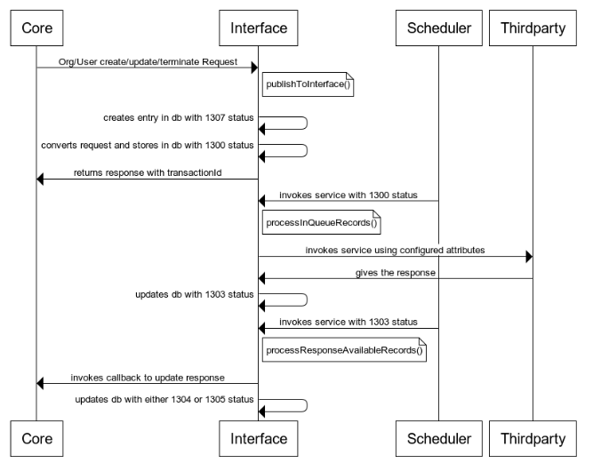

- Query Balance :
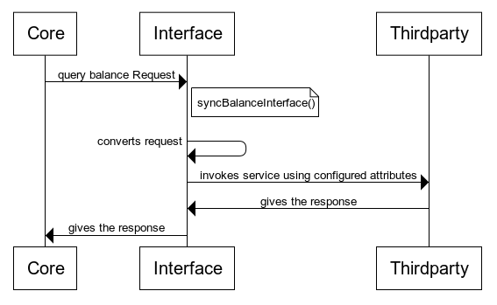

- Transfer Balance :
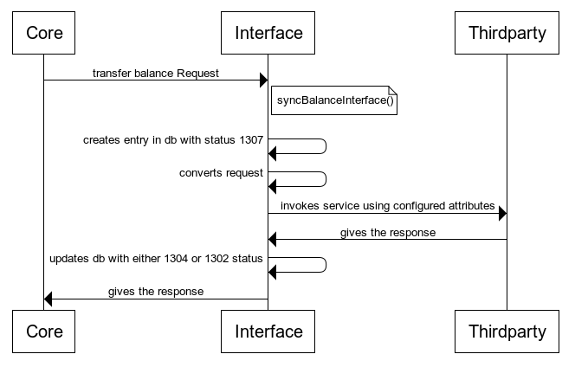

- Query Stock & Create SO :
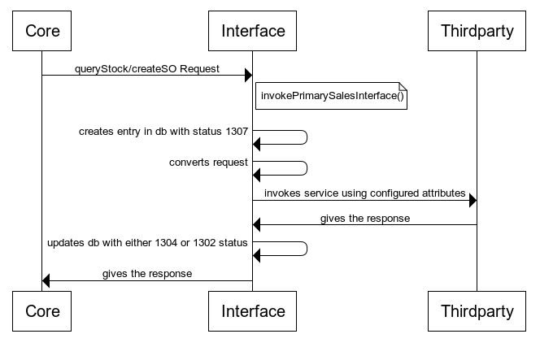

- Incoming Files :
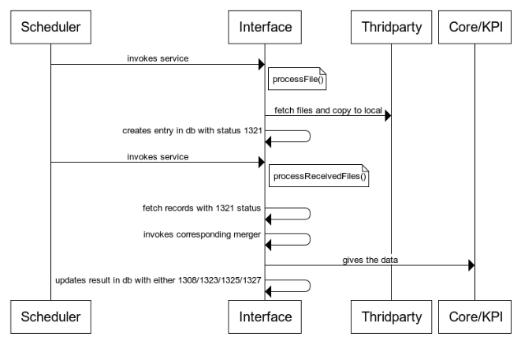

Order Response From Core on Approval Flow :
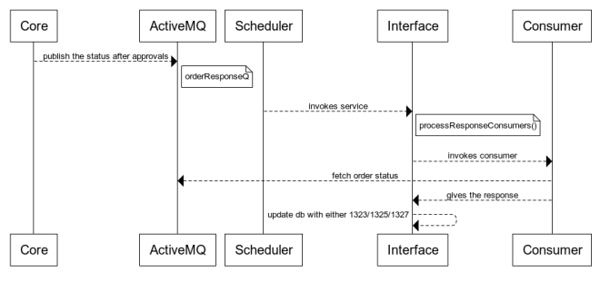
Rejection Flow:
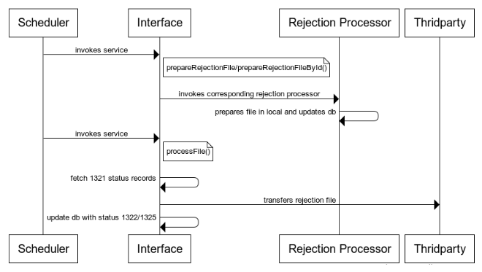

- Outgoing Files :
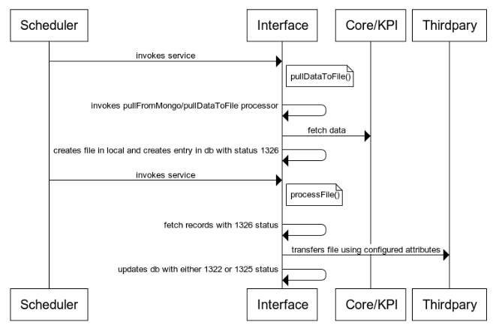

- From Thridparty : (Sample)
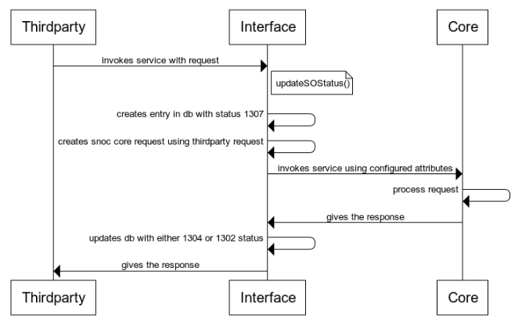

Class Details :

- Entity Service :
Impls :
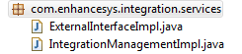
Converters :
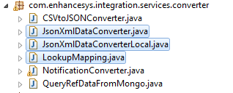
Mergers :
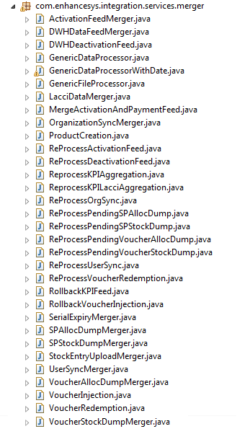
Dump Processors :
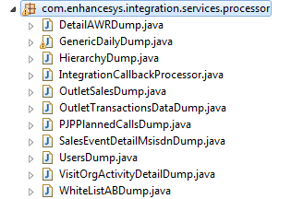
Rejection Processors :
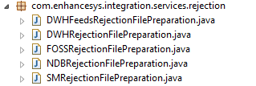
- Consumers
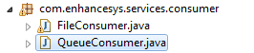
- Publishers
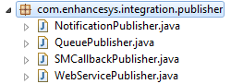

Note : KPI and Generic Dumps related classes contain in entityService springCamel package..

